IAM Lab Assignment.

1. Login into AWS account with the given credentials. Look for the IAM service under Services Category and click on the same. Your IAM page appears as given below

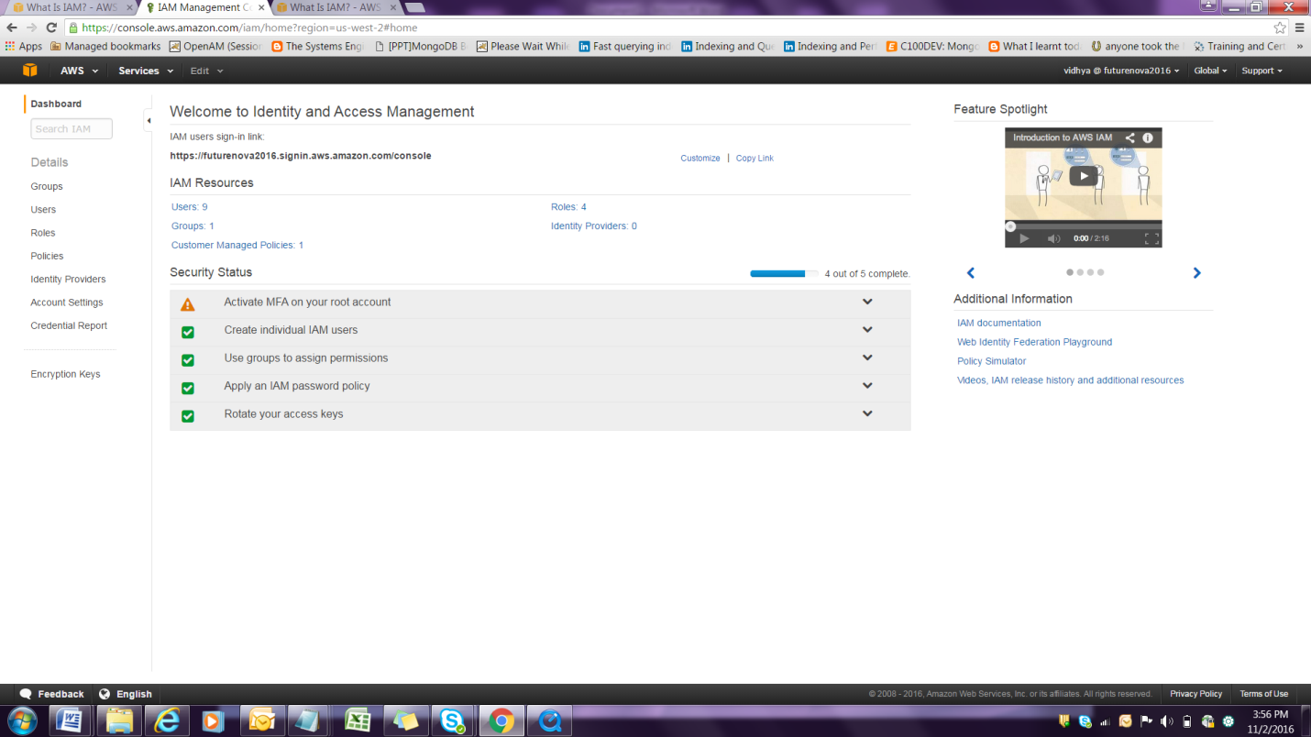

1. To Create Individual Users Click on Create Individual IAM users option as given below

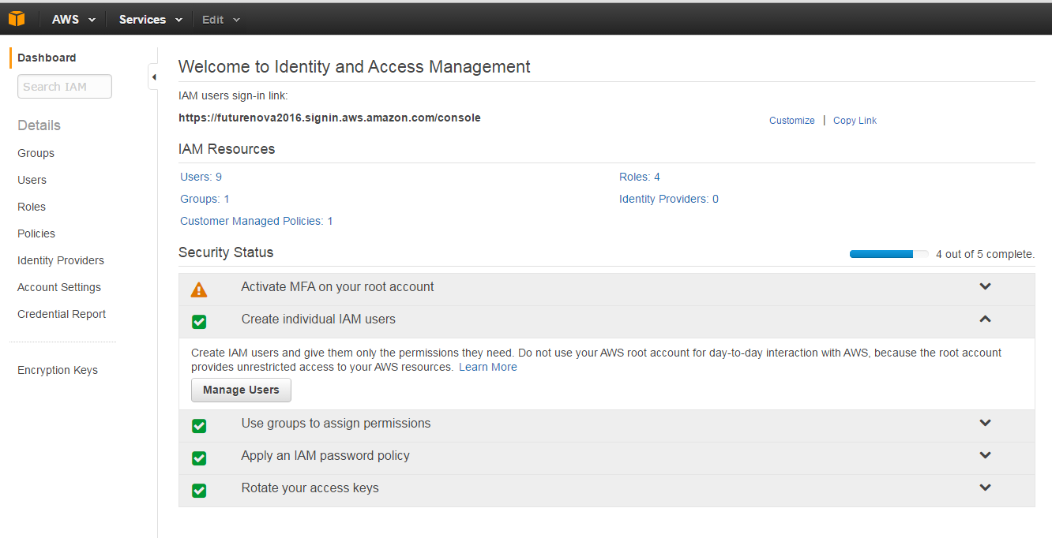

1. Click on Create New users to create New users

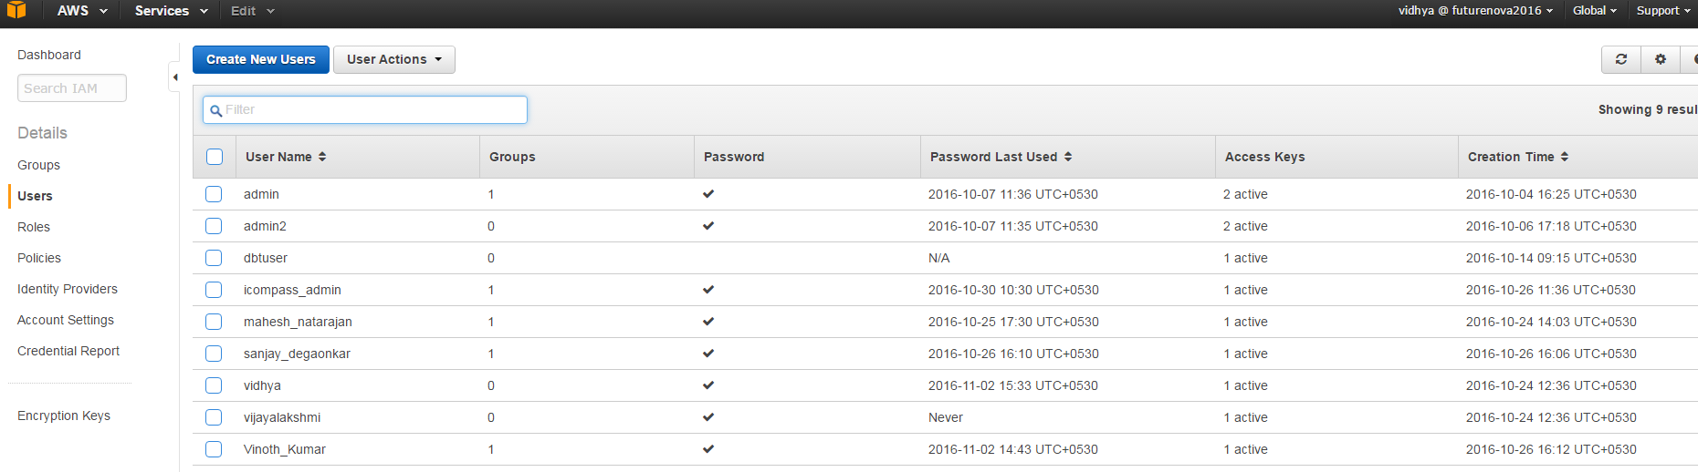

1. Lets create 3 users

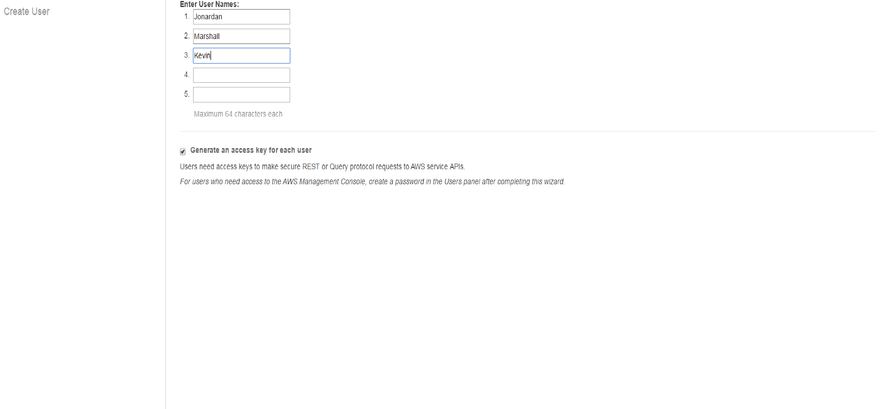



1. Click on Show Security credentials see the Access key and secret Access Key

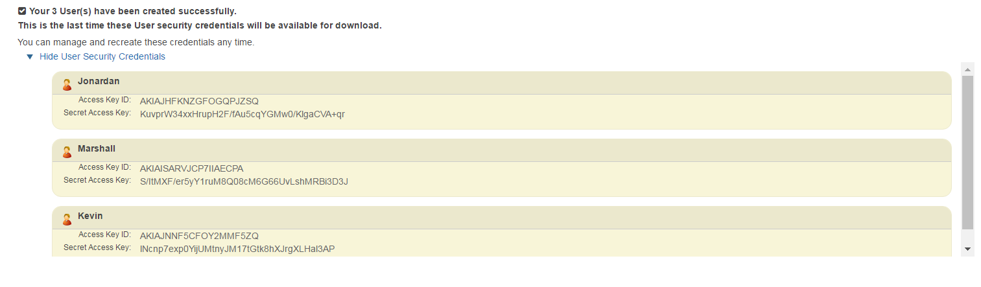



1. Download the credentials by clicking on the Download credentials option .

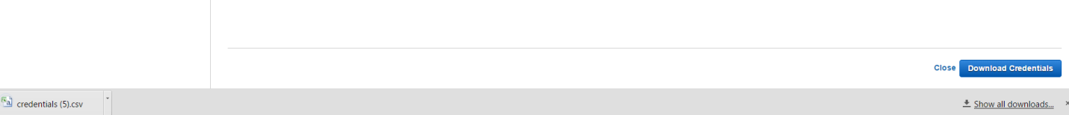

1. Click close and have a look at the users that have been created .





1. To set a password for a user , select the user and click on User Actions drop down list and select Manage Password

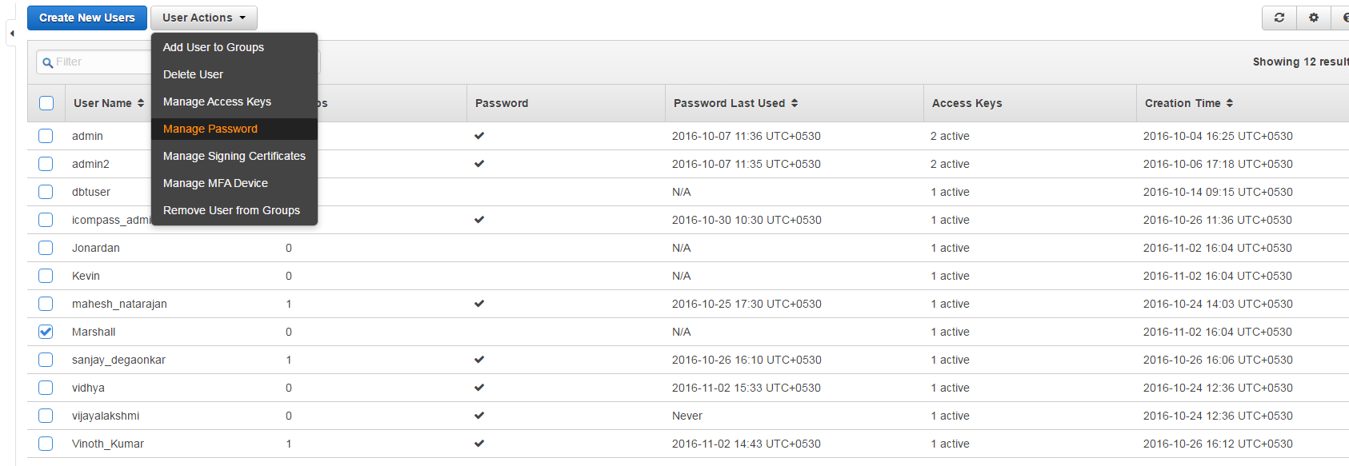

1. Choose a custom password to set a password and choose apply .

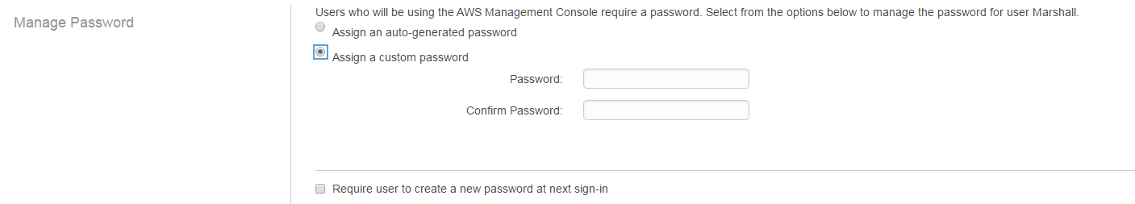



1. See the password tab that is ticked after setting the password.



1. To provide access, click on Policies tab . Attach Administrative policy .

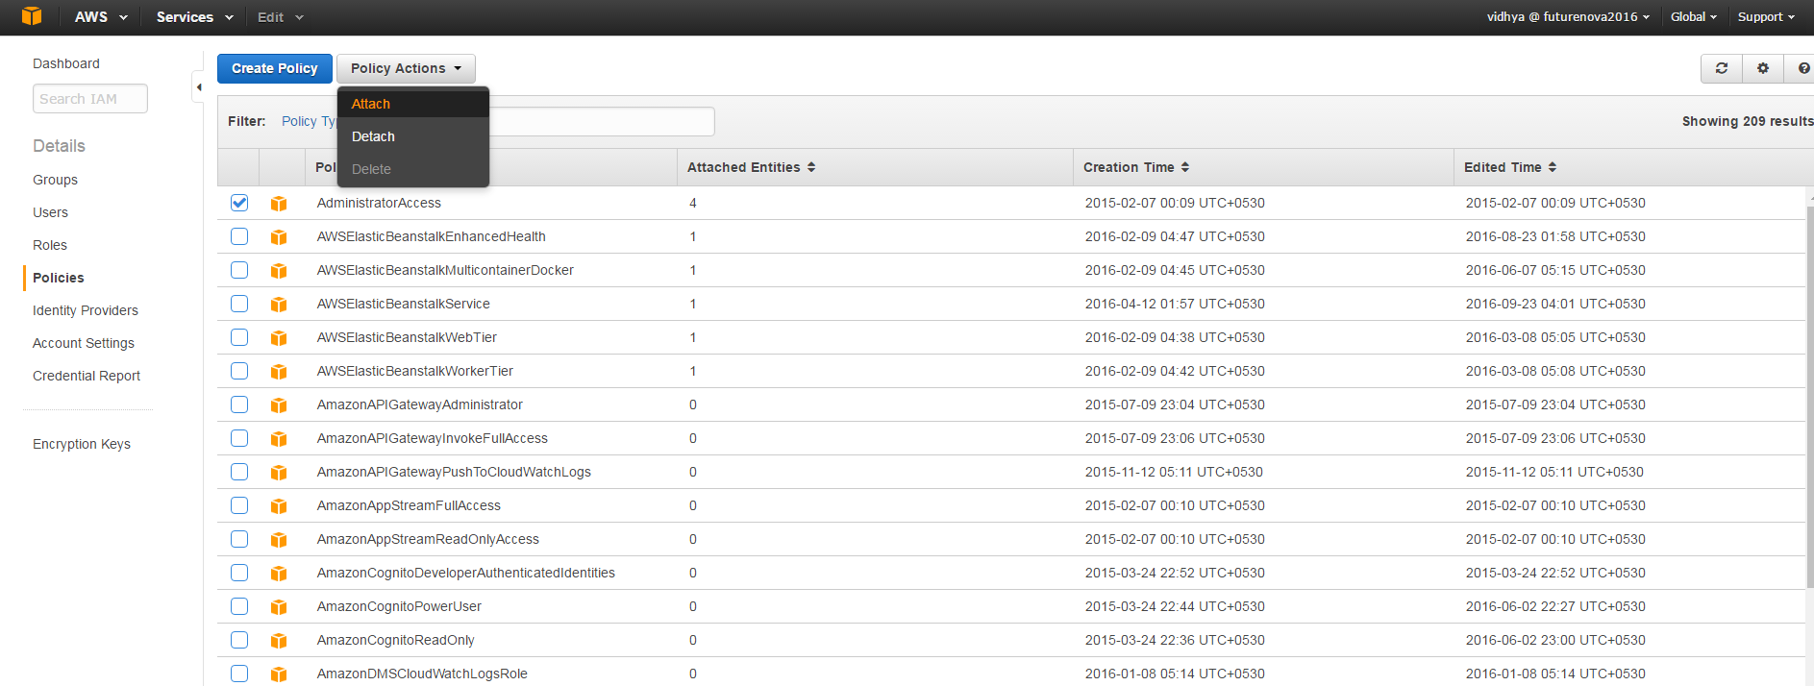

1. Attach the policy to User Marshall .

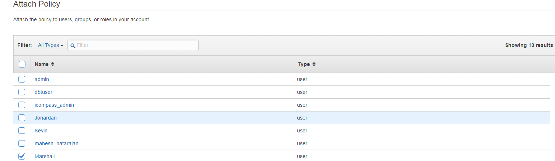



1. To create groups and attach policies to groups and add users to the group .
2. Create a group by clicking on Create New group under Groups option

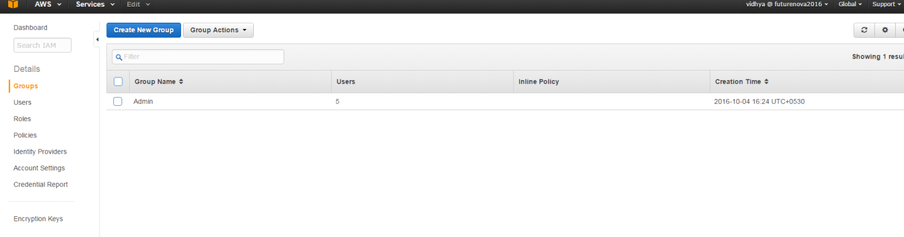

15. Give a Group name as Awsadmin and click on the next step .

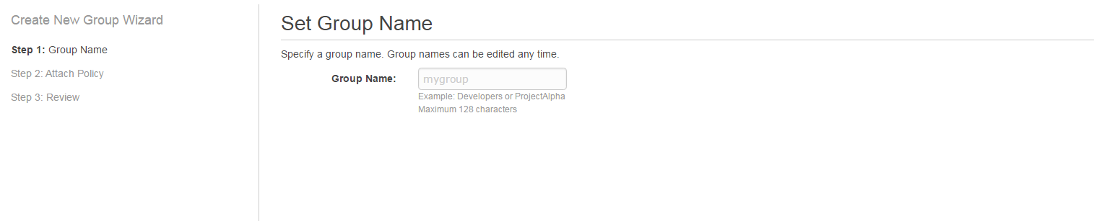

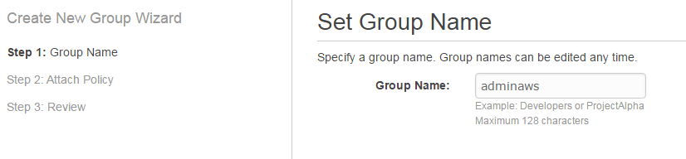

16.Attach the administrative policy and click on Create Group .

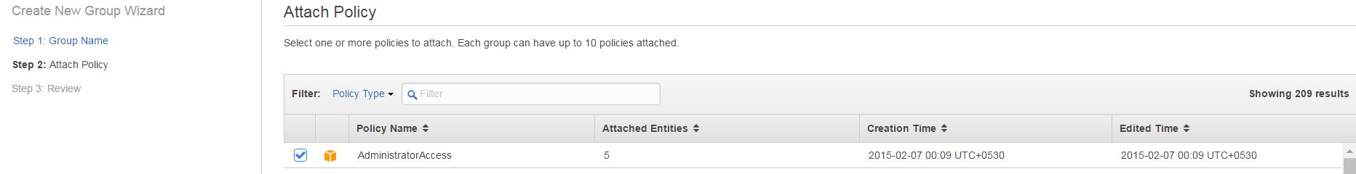



17. Now add users to the Group .

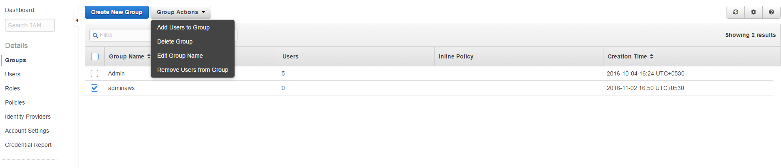

18. click on the users you want to add to the group .







19. To detach the policy from Administrative group click on Policies, select AdminsitrativeFullaccess and choose Detach from Policy Action drop down list.

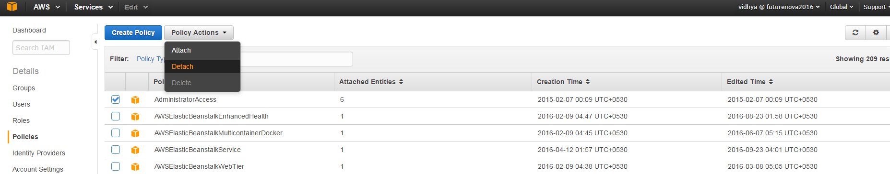

20 . Click on the user from whom the policy has to be detached and click on Detach policy.

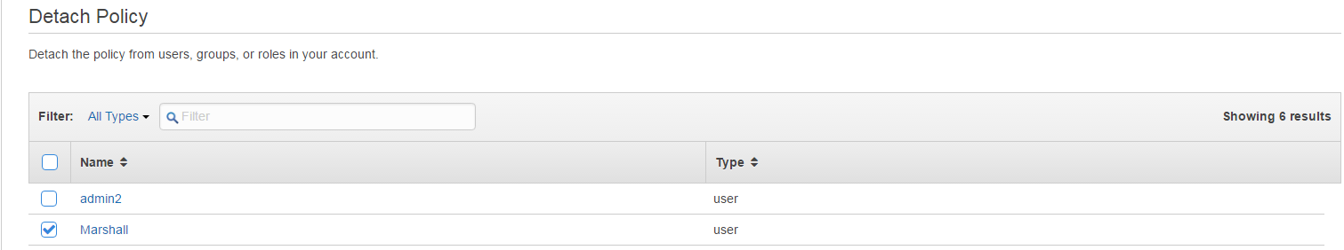



21. Creating a role.

Create a new Role called S3-admin-role

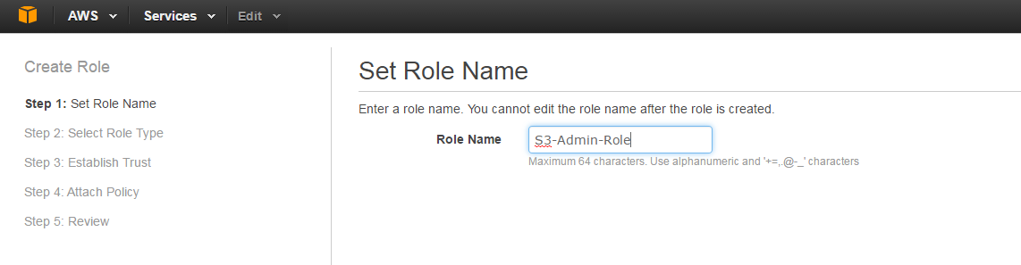

22. Select role Type Amazon EC2 for instance, click Select

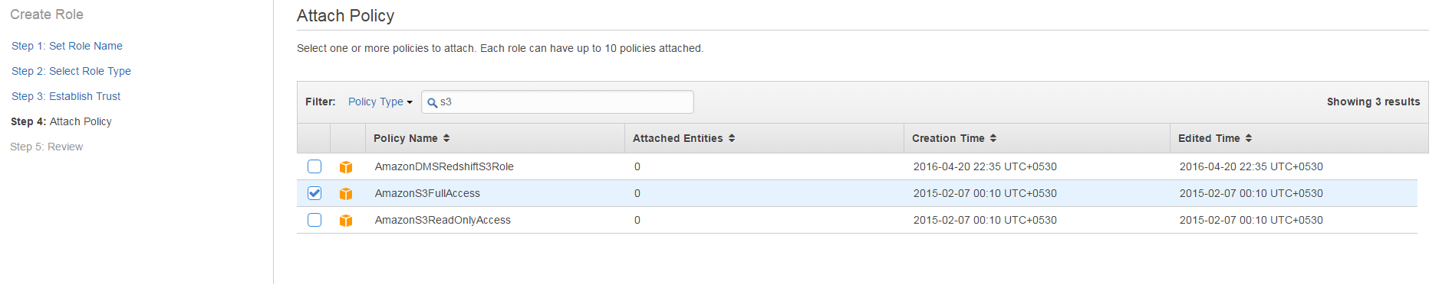



23. Review the role information and click on Create role.

